Description:
Soliton is a top-down stealth game inspired by the Metal Gear Solid series. The graphics are text-based, and the game runs in a terminal window. The levels, including guard locations and paths, are loaded directly from text files.
Rules
The goal of the game is for the player to get from the beginning of a level to the end of a level while avoiding being seen by enemies. Enemies will be represented by a character showing which direction they are facing, and will have a field of view extending four tiles from them, and all tiles within 90 degrees of the line extending directly in front of them. They will not be able to see through walls. When the player gets to the end of a level, designated by the letter 'E', they have won the game, and will be presented with a victory screen.
How To Make a Level
A level file is little more than a map drawn out with ASCII characters. However, the characters should be specific ones to avoid unwanted functionality.
The very last tile of a map should be followed by a '$' character to let the program know to stop loading the map, and begin loading enemy paths. Enemies are ordered from left to right and up to down, and paths are ordered up to down. The first path (Path 0) matches with the first enemy (Enemy 0), and so on.

The proper characters to use during level building are:
'.' - Floor tile. Put these where you want the player to be able to walk.
'-', '|', '+' - Wall tiles. Put these where you don't want the player to be able to walk.
'@' - Player tile. Put this where you want the player to start.
'<', '>', 'v', '^' - Enemy tiles. The enemies are facing in the direction of the symbol's opening, and start the game facing the direction with which they are placed on the map.
'E' – End of level. This is the player's goal, and WILL be displayed to them.
'$' - End of map data. This will NOT be displayed to the user; it is used to signify to the program that it has reached the end of the map.
'#' - Used to signify the beginning of a patrol path. Make sure to put these after the '$' at the end of the map.

A picture of an example map will be pasted into the bottom of this document. It is suggested to use a monospace font and a text editor with line numbering for map-building, to reduce confusion.

How to create enemy path:
A single instruction to an enemy is represented by two characters, and is separated from the previous and next instructions by a single space. The first character is either 'm' for move or 'l' for look. The second character is 'u', 'd', 'l', or 'r' for direction. Moving in a direction will automatically make the enemy also look in that direction. Here is an example path for an enemy:
#mr mr mr mr lu ml ml ml ml ld
Instruction 1: Move right. The enemy moves one tile to the right, and if its orientation isn't already facing right, its orientation is changed to face right.
Instruction 2 – 4: Move right.
Instruction 5: Look up. The enemy's orientation is changed to make them look up, but their location remains the same.
Instructions 6-9: Move left. The enemy's orientation is changed to look left, and their location moves one tile to the left.
Instruction 10: Look down. The enemy's orientation is changed to face downward.

How to control your character:
Your character is controlled with the 'w', 'a', 's', and 'd' keys. 'w' moves your character up, 'd' moves down, 'r' moves right, and 'l' moves left. You must press the enter key after entering a command to have the character move.
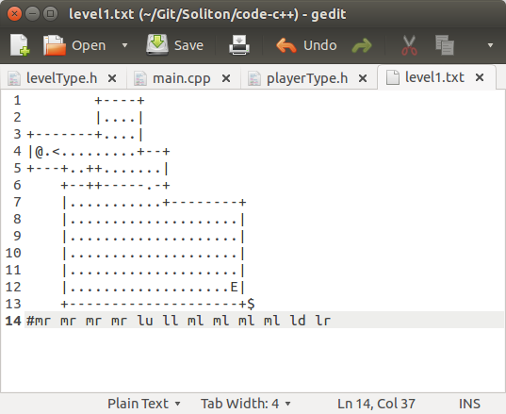
Example level:

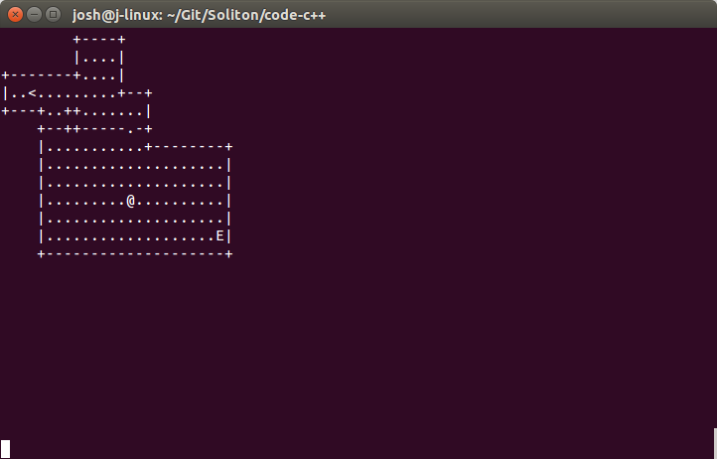
Screenshot:

